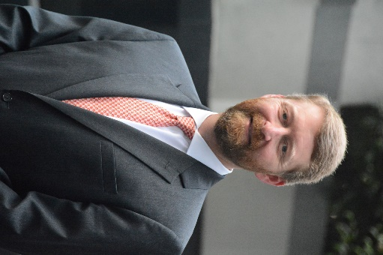
John Loudermilk
President and Chief Executive Officer
Birla Carbon

John Loudermilk is President and Chief Executive Officer, Birla Carbon, based at the Company headquarters in Atlanta, Georgia, USA.
John joined the Carbon Black Business in 2005 as Director of Global Operations. In 2008 he was appointed Vice President of Global Operations with responsibility for global manufacturing facilities along with corporate engineering, quality, and six-sigma. He subsequently took responsibility for the North America business and has led the Technology and Strategy efforts for the Company during his tenure. In January 2016, John assumed additional responsibility for the Europe and Africa region of Birla Carbon. He was appointed Chief Operating Officer in September 2017 and was responsible for all aspects of the Company’s business operations globally. He assumed the role of President and CEO in August 2021.
Over his nearly 30 years of experience in the chemical industry, he has also held a variety of leadership positions within Monsanto and Solutia Inc. with responsibilities across Business Management, Manufacturing, Procurement, Sales, and Supply Chain.
John holds a Bachelor of Science degree in Chemical Engineering from the University of Tennessee at Chattanooga.

About Birla Carbon
Birla Carbon is one of the leading global manufacturers and suppliers of high quality carbon-based solutions. As one of the flagship businesses of the leading Indian multinational conglomerate, the Aditya Birla Group, Birla Carbon provides innovative, sustainable carbon black solutions that enhance the performance of paints and coatings, inks and toners, plastics, adhesives, sealants, textile fibers, mechanical rubber goods, and tires. The company offers high quality, sustainable solutions through Continua™ Sustainable Carbonaceous Material and Sustainable Carbon Black. Birla Carbon is also a global leader in Multi-Walled Carbon NanoTubes with the Nanocyl range of CNTs.
Birla Carbon operates in 14 countries, with 17 manufacturing facilities and three state-of-the-art technology centers in Marietta (USA), Taloja (India), and Sambreville (Belgium), showcasing forefront innovation in the industry. Birla Carbon’s Sustainability Strategy – Share the Future focuses on the ESG pillars of Environment, Social and Governance, with innovation as the driver to achieve its sustainability goals.

